For State of Nevada
Governor’s Finance Office
Budget Division

Nevada Executive Budget System (NEBS)

Work Program Module Manual
Revised September 2023

Table of Contents

Work Program Basics 2
Introduction to the Work Program Module 15
Navigation in the Work Program Module 16
Creating a Work Program in the Work Program Module 20
Workflow in the Work Program Module 27
Reporting in the Work Program Module 30

Work Program Basics

What is a Work Program?
A work program is the document used to request changes to a legislatively approved budget or to establish and/or request changes to a non-executive budget account. It identifies the proposed sources of funds to be received by an agency and shows a plan of how the money is to be spent. It is a mini-decision unit that is self-balancing and must be self-supporting.

There are several reasons for requesting a revision to a legislatively approved budget. Some common examples of reasons for changes are:
- Identify and reconcile changes in an agency’s funding
- Changes to grant/non-grant program funding (increase/decrease)
- Comply with legislation – establish authority relating to a bill (in the year it is effective)
- Transfer authority between categories or budget accounts
- Accept a gift or a grant award (a non-executive account requires a separate action item for placement on the Interim Finance Committee (IFC) agenda if it meets IFC thresholds)
- Increase or decrease authority to collect fees
- Balance forward authority or remaining cash at the end of a fiscal year
- Establish or revise a non-executive budget account
- Establish authority to request and to pay back a General Fund advance (requires request memo)
- Establish authority for IFC Contingency Account funds (requires request memo)
- Request funding for a new position

Documentation
When requesting a revision to an executive budget account or a non-executive budget account, specific supporting documentation is required. Listed below are the items needed to properly justify a work program. Some documents are automatically generated by the work program module, some documents are required attachments to move the work program through the approval process and some documents should be included by the agency. This list is not all inclusive and a work program may require additional or unique documentation.

Module Auto-Generated Documents
- Work Program Checklist – completed checklist populated based on information input into the module.
- Cumulative Sheet – illustrates all previous and current work program changes and can be used as a tool to determine if a work program meets IFC thresholds for approval.

Module Required Attachments
- Work Program Form – agency must fill out the template.
- Cover Sheet – agency must fill out the template.
- Current Budget Status Reports (BSR) from Controller’s Office Data Warehouse of Nevada (DAWN), and/or NEBS 210 reports for the upcoming fiscal year as applicable.
- Budget projections for the budget account through fiscal year-end with corresponding detail including calculations supporting the request by category. Work programs affecting Category 01, Personnel Services, should also include a detailed salary projection by position or by pay period, and calculate balances by funding source.

- Fund map that shows authority before work program and after work program revisions. The fund map must balance to the authority currently in DAWN then display all approved and pending work programs including the work program being presented. The ending column should show the results if the work program is approved. Restricted revenue should identify which expenditures are being supported by that revenue source. If all revenue is unrestricted, this should be noted on the fund map. Work programs affecting Category 01, Personnel Services, should also include a detailed position fund map if more than one funding sources supports this category.

Agency Attachments (as applicable)
- Quotes for purchases of unbudgeted items (equipment, computers, etc.).
- Detailed calculations supporting the request, which ultimately corresponds to the work program amount.
- Detailed Travel Logs.
- Agendas, quotes for airfare or other travel related costs (ie ground transportation).
- Reserve level calculations.
- Reconciliation worksheet showing how the request will be funded.
- The Board of Examiners (BOE) info or action item request (contingency funds, contracts, leases, etc.).
- Grant documents:
  - Copies of grant awards or Notice of Grant Awards.
  - Summary of the grant program and purpose.
  - Grant reconciliations.
  - Grant budget(s).
  - MATCH/Maintenance of Effort summary.
- If requesting a new position, include:
  - NPD-19, before and after organizational charts identifying the new position.
  - Calculations for the cost of the new position. This should include any associated position costs (travel, equipment, approved uniforms, etc.).
  - An explanation of how the additional costs will be funded in the current fiscal year and in future fiscal years.
  - Agency should create a working version in NEBS based on version L01 and attach the resulting NEBS 210 and NEBS 130 reports to the work program to document payroll costs. Assessments such as personnel, payroll, AG Tort, Employee Bond, and information services should not be charged for a new position added during the interim (these should be unchecked in the NEBS position detail screen).
- State Public Works Division, Buildings and Grounds space request form
- Copies of citations referenced in the work program, include only the specific sections necessary. Examples include:
  - Nevada Revised Statute
  - State Administrative Manual
  - Legislative bills – Include cover sheet and pages relevant to the work program
  - Federal or agency specific regulations, etc.
- File Maintenance Request form (Controller’s Office document used when establishing a new revenue GL)
- Category Maintentance Request form (Controller’s Office document when establishing or changing a title for an expenditure category) in PDF format
  - DO NOT attach any interactive forms
  - DO NOT attach forms that are password protected

Prepare work programs using the NEBS Work Programs Module and guidelines presented in this manual. All attachments should be easily understood and legible. Ensure all copies:
- have correct print formatting,
- are scanned straight and of good quality,
- print is not too small,
- white space is used effectively,
- acronyms are spelled out the first time they are used,
- and Excel spreadsheets with formulas are attached in lieu of a pdf.
Concisely articulate the need for the revision and thoroughly document all related information. A well-prepared work program demonstrates the agency has evaluated alternative actions and the proposed change provides the greatest benefit to the state.

Under certain conditions, the Budget Director can approve some work programs, while others require approval by the Budget Director and the IFC of the Legislature. Conditions of approval are detailed later in this manual.

Understand the entire process to get final approval of a work program may take several weeks, so plan well in advance and comply with all deadlines to ensure your work program is approved in a timely manner. Work programs should be prepared and submitted upon the need for the request being identified.

Appropriation vs. Authorization
The source of funds may be categorized as appropriations, authorizations, or a combination of the two. Both represent approval from the Legislature to expend funds. Generally speaking, an appropriation is made from unrestricted state funds, either General Funds or Highway Funds, while an authorization is made contingent upon collecting revenue from another source, e.g., user fees, grants, or assessments.

Work programs are prepared by all agencies in order to comply with the provisions of the State Budget Act - NRS 353.150 through 353.246 and to ensure all of the conditions listed below are met:
- Expenditures are within applicable appropriations and authorizations.
- Appropriations and authorizations are used for purposes that meet legislative intent.
- Sufficient funds exist to allow the state to incur financial obligations.
- Changes in planned revenues and expenditures can be proposed, evaluated, and authorized in a manner consistent with the State Budget Act.

Executive Budget vs. Non-Executive Budget
Upon completion of a legislative session, the legislatively approved budget is electronically incorporated into the Integrated Financial System (IFS). This process is critical for all agencies since revenue and expenditure transactions cannot be processed until the authority is established in the state’s accounting system. If a budget is not included in the Governor’s Executive Budget, the agency must submit a work program to the Budget Division to establish a non-executive budget account each fiscal year.

Work Program Approval Levels
Departmental Approvals
Each department has its own internal process for work programs. The work program module includes several approval levels that can be used by departments based on their protocol, which include:
- Data Entry,
- Budget Account,
- Division, and
- Department.
- NEBS Work Program Access forms can be found on the Budget Division website.

Budget Division Approvals
The Budget Division will review all work programs for accuracy and coordinate the IFC agenda. Work programs not requiring IFC approval can be approved at the Budget Division Team Lead approval level. Work programs placed on the IFC agenda will be held at the IFC Agenda approval level within the Budget Division until approved by the committee.

IFC or Non-IFC Approvals
The Budget Division will use the following guidance, in accordance with NRS 353.220, when determining if a revision requires IFC review and approval:
- The categorical change is more than $350,000 cumulative.
- The categorical change is more than $75,000 cumulative and increases/decreases the category level by 20% or more cumulative.
- Includes a non-governmental grant or gift that exceeds $200,000 each in value.
- Involves the allocation of block grant funds when the agency is using IFC for the public hearing requirement for block grant funds.
Work programs do not require IFC (Non-IFC) approval if they meet the following criteria:
- Is equal to or less than the initial $75,000 cumulative change for the category.
- Exceeds the initial $75,000 cumulative categorical change and increases/decreases the category level by less than 20% cumulative and is less than $350,000.
- Implements general/highway fund salary adjustments approved by BOE.
- Statutory/legislative authority exists that precludes IFC approval.
- Increases revenue and places funds in reserve only.
- Reallocates or realigns revenues with no change to expenditure categories.
- Balances forward remaining authority from the immediately preceding fiscal year without a change in purpose. (353.220 8.b.)

Acceptance of Gifts and Grants
The Budget Division will use the following guidance, in accordance with NRS 353.335, when determining if a revision requires IFC review and approval:
- Gifts, including grants from nongovernmental sources, exceeding $200,000 each in value
- Governmental grants exceeding $200,000 each in value, and
- if the gifts or grants are used for purposes which do involve the hiring of new employees

The Budget Division will use the following guidance, in accordance with NRS 353.335, when establishing or revising a non-executive budget.
- SB431 of the 2023 Legislative Session added Section 6 (f) of NRS 335.335 which states “A gift or grant that will be deposited in a budget account that consists of money which is not appropriated by or authorized for expenditure by the Legislature.”
- In other words, non-executive budget accounts do not require IFC approval through an Action item f regardless of the amount or for hiring employees

Timelines
It is very important the agency submits work programs as they become necessary and highly recommended not to wait until the IFC meeting date is scheduled by the Legislative Counsel Bureau (LCB). Work programs submitted shortly before, on, or after the Budget Division deadline may be postponed to a subsequent IFC meeting if there is not adequate time for the Budget Division to thoroughly review the request. Only the governor can approve exceptions to this policy. The posted schedule of the IFC meeting dates can be found on the legislative website under Calendar of Meetings.

Budget Division deadlines can be found under the Interim Finance Committee link posted on the Budget Division website. If you have any questions concerning deadlines, contact your assigned Budget Officer.

Exceptions
Pursuant to NRS 353.220, exceptions for work programs requiring IFC approval from waiting until the next scheduled IFC meeting for approval are listed below. Agencies should plan accordingly to avoid these exceptions.

Statutory Emergency Provision
Pursuant to NRS 353.220 (5) a), if the work program adjustment is necessary because of an emergency as defined in NRS 353.263 or for the protection of life or property, the governor may approve the work program and must report the action to the IFC at their next scheduled meeting.

Expeditious Action (15-Day)
If the governor determines the IFC needs to take expeditious action to consider a proposed work program, including the acceptance of a gift or grant, the IFC has 15 calendar days (after receipt by the Secretary of the Committee) to consider the work program. If the work program is not acted upon within the 15-day period, the revision is deemed approved (NRS 353.220 (5) b). A request for a 15-day expeditious action should be pre-approved by the Budget Division before the work program is submitted. Extreme circumstances must exist to qualify for an expeditious action and the time needed for review and evaluation of the proposal by the Budget Division is not included in the 15 days. An agency memo (Director or designee) must be emailed to your assigned Budget Officer explaining why the work program is an extreme circumstance and qualifies for expeditious action (example below). Once the 15 day request has been approved, email your assigned Budget Officer as soon as the work programs has been submitted to their approval level in NEBS.

Basic format example of an agency request memo:

Date: (DATE)

To: (BUDGET OFFICER NAME), Budget Officer
Governor’s Finance Office, Budget Division

From: (AGENCY APPOINTINING AUTHORITY, TITLE)
(AGENCY NAME)

Subject: Request for Expedited Work Program Number # C(XXXXX)

Pursuant to NRS 353.220(5) b) the Department of Agriculture is requesting expeditious action on work program # C46647 due to a lapse in receipt of the Emergency Food Assistance Program grant funds.

These funds are essential to continue to reimburse food banks for costs incurred running these programs,without this funding there would be up to four months of delayed payments . This grant includes funding for program costs including food costs, staff salaries to administer the program, food delivery across the state. Without these funds there would be a decrease in food product deliveries negatively impacting low-income Nevadans including the elderly, rural and tribal populations. Per 7 CRF 247.27 the State is required to provide timely disbursement of funds to these local agencies as well as prompt and accurate payment of reimbursement claims, which would not occur if this work program were not to be approved.

45-Day Approval
There may be circumstances where a work program requires approval before the next scheduled IFC meeting. For these situations, the statute has a specific resolution. The IFC has 45 calendar days after receipt by the Secretary of the Committee to consider a proposed work program. If the work program is not acted upon within the 45-day period, the work program is deemed approved (NRS 353.220 (5) c). Note the time needed for review and evaluation of the request by the Budget Division is not included in the 45 days. Email your assigned Budget Officer once it has been submitted to their approval level in NEBS.

It is the preference of the Budget Division to place the work program on the next IFC meeting agenda if it falls within the Budget Division deadlines for that IFC meeting.
Section 7 of the Authorization Act (referred to as Section 10 in the 2019 Authorizations Act) 2023 Legislative Session Added Language
If the operation of an office, department, board, agency, commission, institution or program is financed during a biennium by an appropriation or appropriations from the General Fund or the Highway Fund as well as by money received from other sources, the portion provided by appropriation from the General Fund or the Highway Fund must be reverted to the General Fund or Highway Fund if replaced by a new funding source. General Fund reversions are placed into Category 93, Reserve for Reversion. There is no level of materiality or threshold that applies to a Section 7 adjustment. Also note that a Section 7 adjustment may trigger an inability to access General Fund Salary Adjustment dollars.

In the 2023 Legislative Session, (SB504 for 2023) Section 7 was amended to include the following exceptions:
- Such a decrease must not jeopardize the receipts of such money as is to be received from other sources.
- IFC shall consider, among other things:
  - the reason provided for the exemption, including, without limitation, the current need for the excess appropriated money
  - the intent of the Legislature in approving the budget for the current biennium

IFC Contingency Account Funds and Supplemental Appropriations
Agencies qualifying under the provisions of NRS 353.268 shall submit a request to BOE for an allocation from the IFC Contingency Account funds. Requests for an allocation must be for an emergency use to supplement regular legislative appropriations, which fail to cover unforeseen expenses and to meet expenses pursuant to requirements of law, or as provided by specific statute. Approval of all requests are subject to the independent action of the IFC.

Agencies requesting non-restricted IFC Contingency Account funds are required to submit a memo of request for BOE approval, a memo of request for IFC approval and a complete and accurate work program. All other options of obtaining funds must be exhausted prior to requesting IFC Contingency Account funds unless specified in a legislative bill or other legislation. When a legislative bill includes IFC Contingency Account funds, review the language of the bill closely for requirements and restrictions. For example, BOE approval may not be required when requesting restricted IFC funds.

During a legislative session IFC Contingency Account funds are not available, instead a Supplemental Appropriation may be requested in the agency’s budget request. If approved in the Governor Recommends budget, it will become a standalone bill during that legislative session.

Preparing a Work Program
Work programs are reviewed in the same manner as an agency budget submission and require the same level of detail. Requests must be submitted to the Budget Division with appropriate justification and supporting documentation. A well-documented request will fully answer the following:

- Who will perform the work/services and who will benefit if the work program is approved?
- What is being accomplished and what are the benefits to the population served and/or the state.
- Where will the service/work/project be performed?
- Why is the work program necessary?
- When is the completion date and/or what is the project date range?
- How much is changed from the legislatively approved budget?
- What are the consequences or benefits?

It is important to remember a work program is part of the state’s budget and impacts all other parts of state government in some way, whether directly or indirectly and a complete work program addresses this impact. Additionally, all work program documents and supporting information are subject to public review and some information may be posted to the Nevada Open Government site.

A work program is comprised of several portions and/or forms. These are listed below:

Work Program Form
The financial details and associated comments for a work program are entered on the Work Program Form. Data entered on the form appears in the work program request and work program description reports. The Work Program Form includes a revenue and expenditure section which must balance.

Work Program Cover Sheet
The work program cover sheet summarizes the revision as well as provides clear and concise information to support the request. When completing the work program cover sheet, agencies should remember the audience includes the assigned Budget Officer in the Budget Division, the assigned fiscal analyst at LCB Fiscal, and possibly the IFC and the public. Provide enough information to support the case and present it in an understandable manner. In order for the revision to be approved, all parties must first be convinced it is necessary. Below is a description of each section of the cover sheet.

Budget Account’s Primary Purpose, Function, and Statutory Authority
This section is automatically populated by the module from the Program Statement in NEBS and should be reviewed for accuracy.

Purpose of the Work Program
The purpose of the work program displays on both the work program form and the cover sheet. It is a clarifying action statement and should answer what function the work program would do if approved. It is not intended to describe the mechanics of the work program. Following are examples of the format that must be followed for the purpose section of the work program for various scenarios.

- Balance Forward, No Change in Purpose
  - This work program requests to balance forward unexpended cash with no change in purpose.
- Realign/Additional Grant Authority
  - This work program requests the addition of federal _______(type of) funds to provide _____________ (service/support).
  - This work program requests the addition of federal _______(type of) funds to continue to provide _____________ (service/support).
  - This work program requests the addition of federal Temporary Assistance for Needy Families funds to provide cash assistance payments based on the January 2023 caseload projections.

- Cover Budget Shortfall
  - This work program requests a transfer from the ______ (name of) category to the _________ (name of) category to fund an increase due to __________ (reason).
  - This work program requests the transfer from the ________ (name of) category to the ________ (name of) category to fund a projected shortfall for the remainder of the fiscal year. (If applicable, also identify the type of service that the funds are to be used for.)
  - This work program requests a transfer from the Reserve category to the Division Cost Allocation category to fund an increase to the division’s federal indirect rate agreement.

- Request Item Missed in the Budget Request
  - This work program requests a transfer from the ________ (name of) category to the _______ (name of) category to cover ____________________ (reason).
  - This work program requests a transfer from the Information Services category to the Personnel Services category to fund contracted IT Programmer staff needed to support the MyAvatar system.

- Request Authority for New Program/Requirements
  - This work program requests a transfer from the ________ (name of) category to the ________ (name of) category to _____________________ (reason).
  - This work program requests a transfer from the Reserve category to the Personnel Services category, from the Reserve category to the Operating category, and from the Reserve category to the Loan Servicing category to support the Loan Surviving Program recently acquired by the Housing Division.

- Request Authority for Requirements Passed During the Legislative Session, Not Included in the Budget
  - This work program requests the addition to _________ (name of) fees to Section _____of the _____Legislative Session.
  - This work program requests the addition in Qualified Equity Investment Application Fees and in Cost Allocation Reimbursement funds to add a Management Analyst position to provide support in development and implementation of the program regulations and financial oversight for the New Markets Job Act and to assist in the development and support of the new directives of the Industrial Development Revenue Bond Program for charter schools pursuant to Senate Bill 357, Section 16 and Senate Bill 384 of the 2023 Legislative Session. (example only – these bills do not exist).

- Companion Work Programs
  - This work program is a companion to work program #CXXXXX. (This is required of work programs that are contingent upon approval of the companion work program)

Justification
A complete presentation will include a thorough statement of justification. Justifications should assume the reader has no knowledge of the issue at hand. Listed below are questions the justification summary should answer.
- What is currently being done by your agency or other agencies to address the issue and why are current efforts insufficient?
- What facts and figures support the policy and fiscal recommendation?
- What facts and figures support the revision to each affected category?
- What statements or information from authorities and clients support the request? What support or opposition is there to the request?
- Are there legal considerations?
- Why wasn’t this issue addressed during the legislative session?
- Will this proposal actually solve the problem?
- What is the impact on other state departments? Document coordination with these entities and note any companion work programs.
- How is this proposal consistent with the department’s strategic plan? Be as specific as possible.
- At a minimum, identify the objectives this request will support.
- Is each component in the proposal absolutely essential or just desirable? What recent program changes have occurred causing the request?
- Are or can other non-state funding sources be made available?

Below are sample justifications for reference:

- Balance Forward, No Change in Purpose
The Bureau of Health Care Quality and Compliance charges fees for applications, licenses and renewals of health care facilities, medical laboratories and personnel. Pursuant to NRS XXX.XXX, cash on hand at the end of each fiscal year must be balanced forward in the same budget account for use in the subsequent fiscal year.

- Realign/Additional Grant Authority
The Immunization Program is federally funded and typically receives three rounds of funding per calendar year from the Center of Disease Control. Additional revenue and expenditure authority is needed to establish the first round of funding for calendar year 2022. In addition, a re-alignment in expenditure categories is needed to reconcile state authority. This grant not only funds the operation of the Immunization Program, but it is also used to support two immunization coalitions and three health districts. These coalitions and health districts conduct mandatory activities on behalf of the Nevada State Immunization Program. Please note that standard operating categories are being collapsed into the special use category for ease of tracking due to federal reporting requirements.

- Cover Budget Shortfall
As a result of legislatively approved step increases and being fully staffed during fiscal year 2021, Category 01, Personnel Services, has a budgetary shortfall. Category 26, Information Services, has sufficient surplus to cover the shortfall. The surplus in Category 26 is due to reduced costs negotiated for the Emergency Management System web server contract. Accordingly, the division is requesting approval to transfer authority from Category 26 to Category 01 to cover the budgetary shortfall.

- Request Item Missed in the Budget Request
During the 2017 legislative session, the division overlooked the need to request authority in Category 26 to cover a contracted IT Programmer for the division’s MyAvatar system used to capture client data and manage the division’s behavioral health caseload. The programmer is needed to add a module to the MyAvatar system to capture data and caseload statistic information for the new Mobile Outreach caseload approved in AB 408. It is anticipated it will take the programmer approximately 960 hours to add the new module; please see Attachment A for a breakdown of estimated cost per hour, and number hours needed, for each contract deliverable.

- Request Authority for a New Program/Requirement
Rural counties are struggling to comply with the Centers for Medicare and Medicaid Services’ mandates which limits their ability to maximize Medicaid reimbursement. This lack of Medicaid funding translates to additional state General Fund needed to support county residents in the area of mental health. Accordingly, the division is proposing to transfer authority from Category 86, Reserve, to Category 04, Operating, which will be used to contract with a vendor who is well versed in Medicaid billing practices to provide one two - day training each month in fiscal year 2021 at key locations throughout Nevada. This training will enable counties to maximize Medicaid funding which will reduce the amount of state General Fund needed for mental health services. Please see Attachment A for anticipated training locations and projected costs.

- Request Authority for Requirements Passed During the Legislative Session, Not Included in the Budget
SB 374 of the 2017 legislative session allows for the registration of medical marijuana establishments authorized to cultivate or dispense marijuana or manufacture edible marijuana products or marijuana-infused products for sale to persons authorized to engage in the medical use of marijuana; the registration of agents who are employed by or volunteer at medical marijuana establishments; setting forth the manner in which such establishments must register and operate; creating the Subcommittee on the Medical Use of Marijuana of the Advisory Commission on the Administration of Justice; and requiring the Health Division of the Department of Health and Human Services to adopt regulations.

This work program requests authority for two temporary, full-time contract employees. One employee will be an attorney position who will be responsible for developing and drafting regulations pursuant to Section 24 of SB 374. The other employee will be a management analyst position who will be responsible for planning for and establishing the program changes that will be needed to meet the requirements of SB 374. This position will be responsible for determining any new personnel and associated resources that will be required to carry out the requirements of the bill.
This request includes authority for five employees to travel to Arizona. Arizona has already successfully implemented a medical marijuana dispensary program. Staff will travel to assess that state's regulatory oversight and understand operations at the dispensary and grow sites. Travel is requested at the current U.S. General Services Administration (GSA) rates. Authority is also requested for a new needs assessment contract to identify capacity and assist with capacity development. A vendor will be determined once authority is in place for the contract.
This request also includes authority for operating supplies and computers for the two temporary employees. Authority is also requested for the increased postage costs the program has experienced during the last six months of fiscal year 2017 as well as for the costs of regulation development, as required in Section 20 of SB 374.
Expected Benefits to be Realized
The work program should identify what goals or objectives are to be achieved and include a discussion or provide the criteria by which the success or benefits of the request can be judged. The discussion should also include any adverse impacts if this proposal is not approved. Be realistic in this assessment. This section should also include time frames and the effect on future biennia. As an example, if a proposal were to establish a pilot or new program, the request should include performance measures to evaluate the success of the program. That is, the proposal should set forth a plan including who will evaluate, how and when the evaluation will be conducted, and what will be measured.

A work program requesting a new project should also discuss the projected implementation time and effect, if any, on future biennia. Include a timetable for implementing the request, i.e., the timing of the necessary steps. Be certain to take into account factors that are beyond your control such as obtaining licenses or certifications. If the program requires multiple steps, determine if these are to be performed sequentially or simultaneously. What sort of delays might you reasonably expect to occur? What is the potential impact of those delays? Is there any way to avoid them and does this delay come at a cost?

In many cases, this section is direct and to the point, with little detail necessary. Examples of these cases include:
- Balance Forward, no change in purpose.
- Realignment of authority for a current grant.
- Fund a projected budget shortfall.
- Request for an item missed in the legislatively approved budget.
- Request for authority for requirements passed during the legislative session, but funding was not included in the budget.
- Request for salary adjustment funds.

In other cases, a detailed explanation is necessary to supplement the information given in the Purpose/Justification sections. For these cases, additional information not provided in the Purpose/Justification sections should be added here. See examples below:

- Allow Receipt of Additional Projected Revenue for a New Program
Approval of this request will allow the Department of Employment, Training, and Rehabilitation to adequately fund services to potential employees and employers to improve Nevada's workforce. This training supports economic diversification efforts by creating a skilled workforce and assisting clients to return to work.

- New Federal Grant Received from the Department of Health and Human for the Title X in Nevada Health Insurance Enrollment Program
This program will expand eligibility and enrollment outreach activities at four existing Title X service delivery sites to assist the uninsured clients accessing clinic services to enroll in health insurance or Medicaid through the Silver State Health Insurance Exchange. This expansion, for current and potential clients, will provide information and assistance to understand and identify the affordable coverage that best meets the client's needs. This will enable better access to high quality family planning and other health preventative services. The four existing sites that have been chosen are located in Northern Nevada in counties considered to be rural and frontier: Carson City, Churchill County, Lyon County, and Humboldt County. Nevada family planning clinics expect to reduce the overall percentage of uninsured clientele with this program.

Attachments
Supporting documentation added under the attachment section of the Work Program module should include, at a minimum:
- Spreadsheets with calculations (and accessible formulas) which tie back to the work program and clear description for the origins of amounts. This includes fund maps and detailed categorical projections identifying authority needs.
- A copy of the grant award, if applicable (attached only the portion of the award which pertains to the work program).
- For a provisional grant request, the application and/or documentation for the grant and amount
- Any other documentation that supports the request.

Attach documents quantifying workload and cost information that is the basis for determining the level of activities that must be performed and the related number of full-time equivalent employees requested and the dollars requested. If the request involves a new program for which actual workload data are unavailable, the workload assumptions and the basis for those assumptions should be clearly set forth in the supporting documentation. Supporting documentation should include functional descriptions of what staff or other resources will accomplish if the work program is approved.

Common Pitfalls
Completing a work program request can be a tedious, complex process. Failure to provide documentation required by the Budget Division can result in the delay or rejection of the submitted work program. Ensure the agency has reviewed the need for the work program as objectively as possible. Common problems to avoid in requests include:
- Untimely submissions (start the work program early and strive to complete all requests in advance of Budget Division deadlines).
- Missing supporting documentation (fiscal year-end expenditure and revenue projections, quotes, grant reconciliations, grants awards, etc.).
- Amounts in supporting documentation or narrative don’t match the request
- Narrative does not clearly explain the revision request
- Grant reconciliation does not match request, does not tie to DAWN, does not tie to grant awards, and/or supporting calculations are incorrect or not detailed enough.
- Work programs are combined to address more than one purpose/decision.
- Transferring between categories isn’t justified for all categories affected.
- Transferring more out of a category than is currently available (expenditure was completed after work program completed)
- Information is not basic and clear enough for someone who doesn’t work at the agency to understand.
- The final submittal is not reviewed by the agency in its entirety prior to submittal for overall completeness and appropriate print formatting.
Hard coded numbers in fund maps and other spreadsheets.
- Detailed Travel Log not provided when requesting travel funds (use PCN # or title to identify traveler)
- Requesting items that were previously requested but were not approved, either by the Budget Division or the Legislature.
- All necessary companion work programs are not submitted together and cross-referenced in the narratives.
- Retroactive requests – money shouldn’t be spent until the work program is approved
- Not labeling new RGL’s or categories so NEBS labels as “TITLE NEEDED” (needed when file maintenance is attached).
- Category numbers and amounts being included in the Purpose of the work program.

Professional Presentation
While the content of the work program should be the highest concern, presenting the information in a logical, readable fashion is very important as well. A poorly organized, illegible work program request, even if it is well-documented, can result in the delay or rejection of the request.

Follow the guidelines below:
- Make sure all copies scanned and attached are of good quality. Attachments must print to letter-sized documents (8½” x 11”).
- Files must be clear of passwords, hyperlinks, macros, electronic signatures, or other interactive files. This is very important since having these items in the file will cause the document to print incorrectly and could hamper the system’s ability to process the request.
- Make sure scans are placed in the same direction. Make sure all attachments are legible and understandable when printed. Check for crooked copies, highlighted areas on originals that blackout text on copies, illegible print, etc.
- Make sure all attachments are formatted correctly so there are no partial or blank pages attached.
- Make sure submittals include attachments of cited information such as NRS, legislative bills, federal or agency specific regulations, etc. (only include pertinent sections).
- Make sure all attached Excel workbooks include only applicable tabs and that spreadsheets are correctly formatted for printing and presentation.
- Use 10-point font or greater. Helvetica or Times fonts are preferable. Avoid small, illegible print.
- Set small margins on spreadsheets so print is larger and easier to read. (Use the white space.)
- Spell out acronyms the first time they are used.
- Calculations on backup documentation must tie to amounts on the work program.
- Organize supporting documentation.
- Do not include any personal identifying information.
Introduction to the Work Program Module

Overview
The NEBS work program module is used in the preparation and submittal of work programs. (The Work Program Basics section should be understood before proceeding with this section.)

IFC Meeting Support
As previously outlined some work programs will require IFC approval and others won’t depending on such things as the dollar amounts involved, the source of funding, cumulative changes that have been made to that program, etc. Some of these items can be identified by NEBS while others will require that the assigned Budget Officer assess the situation. In all cases, NEBS suggested course of action can be overridden by the user and the final yes or no decision as to whether a given work program requires IFC approval will be made by the assigned Budget Officer.

Features
Some of the features in the module for building and managing work programs include:
- Word, Excel or PDF files may be attached to provide supporting documentation.
- An active spell check helps keep your text free of errors.
- Drop-down menus for revenue GLs and object codes populate fields automatically.
- Titles may be customized for revenue GLs and categories.
- Print options for the entire work program request or only the specific documents you need.
- Prior work programs may be searched and referenced online.
- The status of a work program may be reviewed at any time.

Executive and Non-Executive Budgets
The module accommodates both executive and non-executive budget account work programs. At the beginning of each fiscal year, NEBS is loaded with the legislatively approved budgets while non-executive budget accounts will be initiated by the agency with a balance forward work program. NEBS will automatically update the cumulative amounts for subsequent work programs.

Navigation in the Work Program Module

The NEBS tab is the default when you sign in. At the top of the page, click on the Work Programs tab (shown below). If the tab is not visible, verify the NEBS Work Program Access form has been submitted to the Budget Division. There are four primary sections on the Work Programs home page described below.

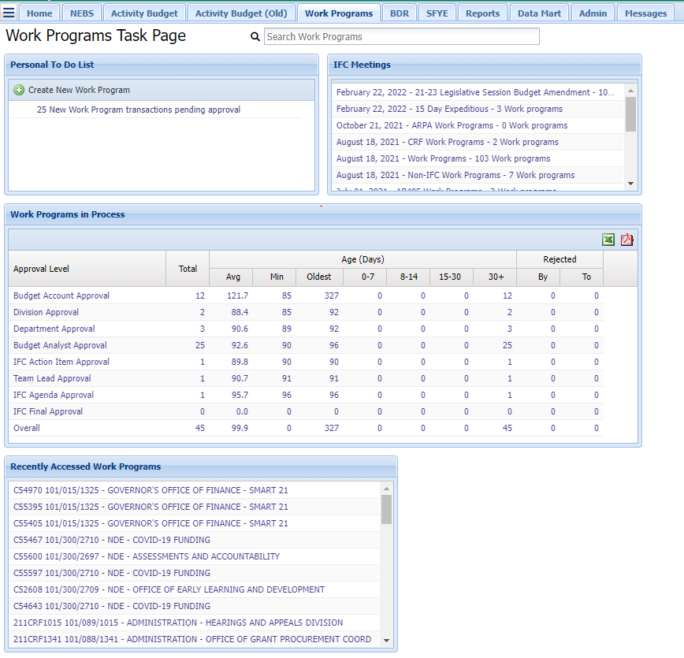

- Personal To Do List Section
The Personal To Do List section will show how many pending items require action. Clicking on the link for pending items will show a list of those items. The list will also show any work programs you have entered that have been rejected. Click on the link to display the item and the message submitted by the reviewer who rejected it. Deleting a work program from a user’s list is just that, it only removes it from the user’s view not the system. The work program can only be completely deleted by the person who initially drafted the work program.

- IFC Meetings Section
The IFC Meetings section will show currently scheduled meetings. Selecting an IFC meeting date will populate the work programs currently included on the respective agenda.

- Work Programs in Process Section
This area shows a summary view of items in the approval queue. To help manage the workflow of pending work programs, this section provides the Work Programs in Process dashboard. The dashboard displays the queue of pending work programs and allows them to be managed based on the age of the documents at the various stages of approval. Use of the dashboard will help ensure work programs do not get ‘stuck’ at some stage in the approval process. The dashboard will create summary reports of work program aging and provides the ability to ‘drill down’ to view the individual work programs. The workflow dashboard is particularly useful in obtaining an executive level view of the status of pending work programs (shown below).

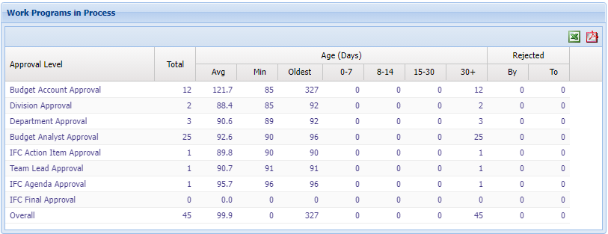
- Recently Accessed Work Programs Section
This is a list of the work programs most recently accessed. Each item in the list links to a detail page for that work program (shown below).
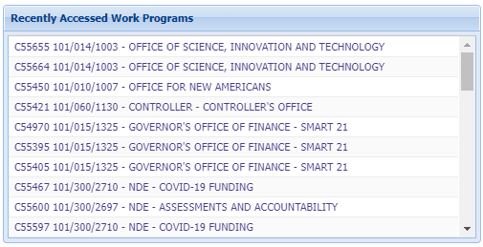
Work Programs Task Bar
To access the Work Programs Task Bar, either click on the three horizontal lines icon or click on the Advance Work Program Search to the right of the Search Work Program box to open that portion of the screen (shown below). This area features links to key tasks described below.
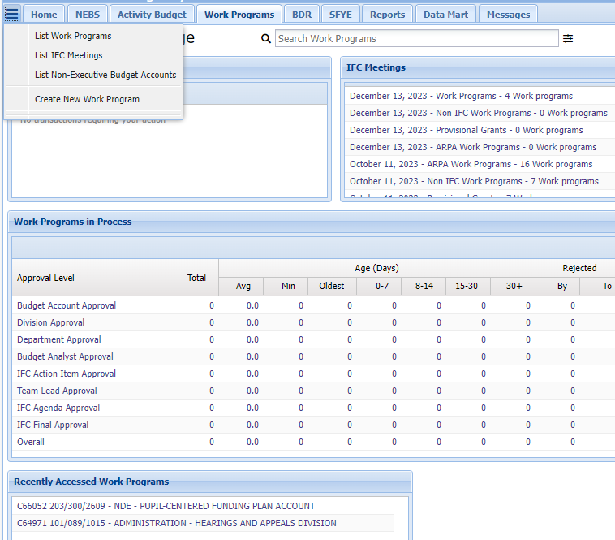
The Work Program Task Bar - Allows a user to list work programs, IFC meetings, non-executive budget accounts, go to a specific work program, and create a new work program.

List Work Programs - By choosing the list work programs link, a filter is provided (shown below) to produce lists of work programs customized for various reporting needs. Results will appear in the field below the filter selections grid. Examples of possible filters include:
- Fiscal Year
- Status – Shows approval level within department, division or a particular reviewer
- Department
- Division
- Budget Account
- Work Program #
- Containing Text
- Type – Work program or budget amendment
- IFC Meeting Date
- Work programs that require IFC approval or show only those that do not.
- State Fiscal Year-End (SFYE) work programs.

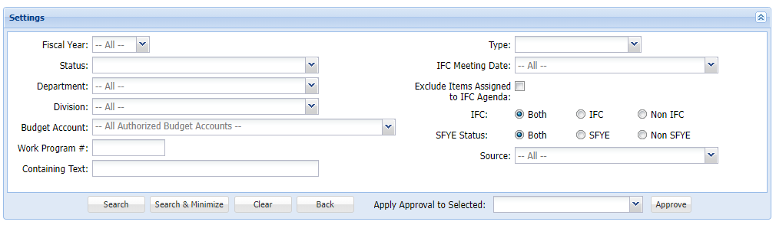

Creating a Work Program in the Work Program Module

Creating a New Work Program
- Either click the Create New Work Program link in the work program task bar or click the Create New Work Program button on the main page. The Create Work Program Checklist screen will be displayed. The work program number will automatically populate. A user can manually determine a work program number, but this is uncommon and it is preferred that the number provided by NEBS be used.
- Select the appropriate fiscal year.
- Select a budget account. The department, agency and fund information will automatically populate when the budget account is selected.
- Select the type of work program.
- Click the Create button (shown below) and the main Edit Work Program Checklist page will be displayed.

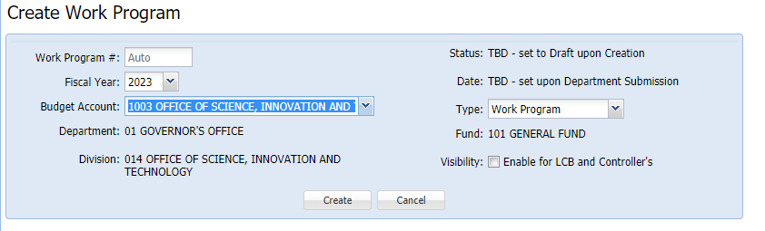
View Work Program
After the user saves this information described above, the View Work Program page populates. The View Work Program page shows the following information:
- The work program number and fiscal year.
- The agency and account information.
- The work program status and date
- The type of work program. This can be either ‘Work Program’ or ‘Budget Amendment.’ The ‘Budget Amendment’ choice is only available for use during the legislative session and should be approved in concept by the Budget Division prior to submittal.
- The Work Program Checklist (shown below) displays on the left side of the screen and includes a list of items required to provide for any given work program and the ability to attach files that will be included in the work program request.

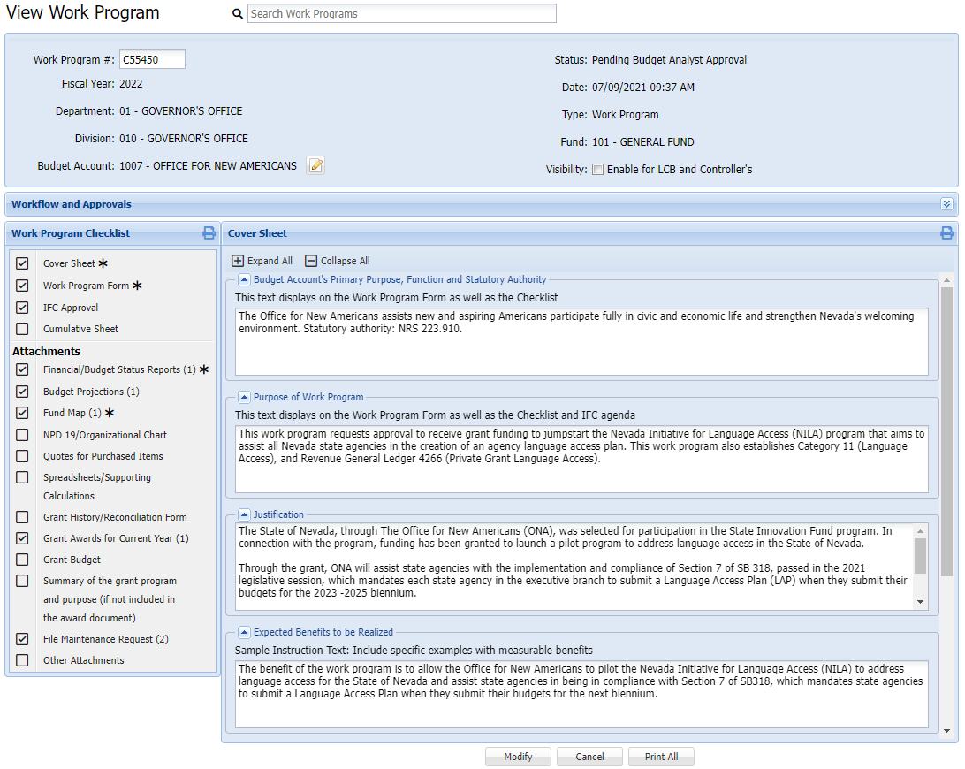
- Work Program Checklist (system generated)
- Cover Sheet
- Work Program Form
- IFC Approval
- Cumulative Sheet (system generated)

- Attachments
The attachments under the work program checklist allows inclusion of the following types of documents within the work program:
- Financial and Budget Status Reports (required by NEBS prior to submittal)
- Budget projections including salary and travel if applicable
- Before and After Fund Map (required by NEBS prior to submittal)
- NPD-19s and organizational charts
- Spreadsheets and supporting calculations
- Referenced items in the work program (NRS, bill, work program, etc. – pertinent pages only)
- Grant history and reconciliation forms
- Grant awards for the current fiscal year
- Grant budget information
- Summary of the grant program and purpose (note a grant award is sufficient, you do not have to submit the grant proposal)
- Provisional grants need at least the grant application or similar documents of the grant and amount
- File maintenance requests (make sure this is not an interactive document)
- Other attachments (as necessary to help justify your request)

To attach a file, click relevant attachment title (shown below), when the Files to Upload box appears, click Select a File to Upload and upload the file. Select the file, name it properly and click Open. Users can also attach a file by “dragging and dropping” a file into the Files to Upload box.

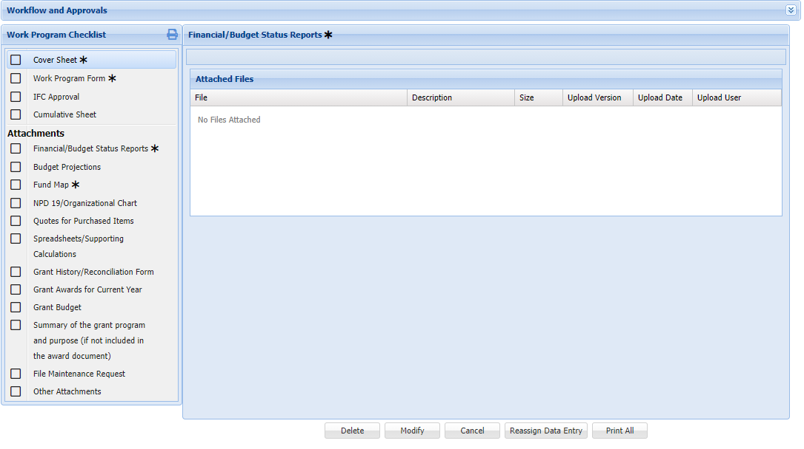
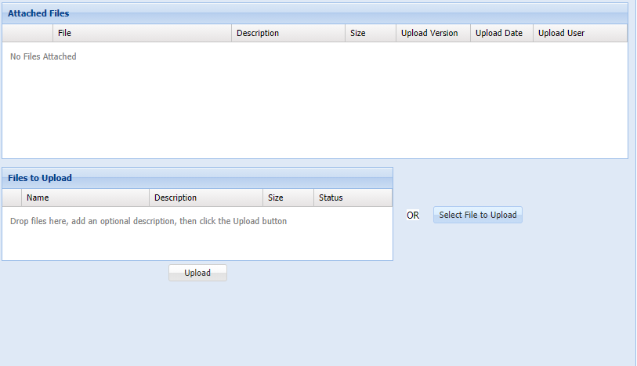
IFC Approval
The Budget Division uses the IFC Approval section to define the following work program features:
- IFC Approval Type (shown below)
- IFC approval requirements for work programs are listed with radio buttons. Choose the appropriate IFC approval requirement. Refer to the criteria listed under “This Work Program does NOT require IFC approval because.”
- The Agenda Description will be completed by the assigned Budget Officer.
- The remaining radio buttons are the criteria for the work program NOT requiring IFC approval. Choose the appropriate reason the work program does not qualify.
- Allow IFC agenda tracking is a feature used by the Budget Division only.

The agency will make the selections when preparing the work program, but note the Budget Division reviews these selections and will make changes as deemed necessary.

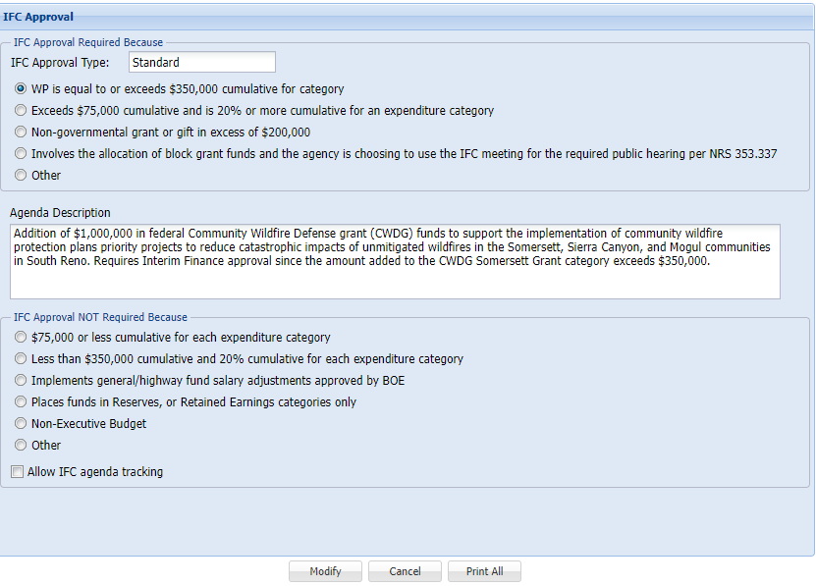

Work Program Form
The financial details and associated comments for a work program are entered on the Work Program Form page. Data managed on this page appears in the work program request and work program description reports. The following tools are available:

Revenue Grid
The revenue grid/ Funds Available grid (shown below) shows the current authority for the budget account associated with the work program. Increased or decreased amounts entered must balance to the corresponding increase or decrease in the expenditures grid or an adjustment to another RGL. In summary, the total of all grid adjustments must equal zero.

Expenditures Grid
The Expenditures grid (shown below) shows the current expenditures by category for the budget account associated with the work program. As with the revenue grid, the work program adjusts these amounts and any increase or decrease to the total expenditures must balance with a corresponding increase or decrease in the revenue grid or expenditure GL. Selecting the appropriate object code within each category is required. Generic GLs can be used for expenditures (i.e., 7000 for operating); however, detail for the actual line item is lost when using the the generic GL. Reserves – category 86 must use GL 9178 so NEBS will identify this line item.

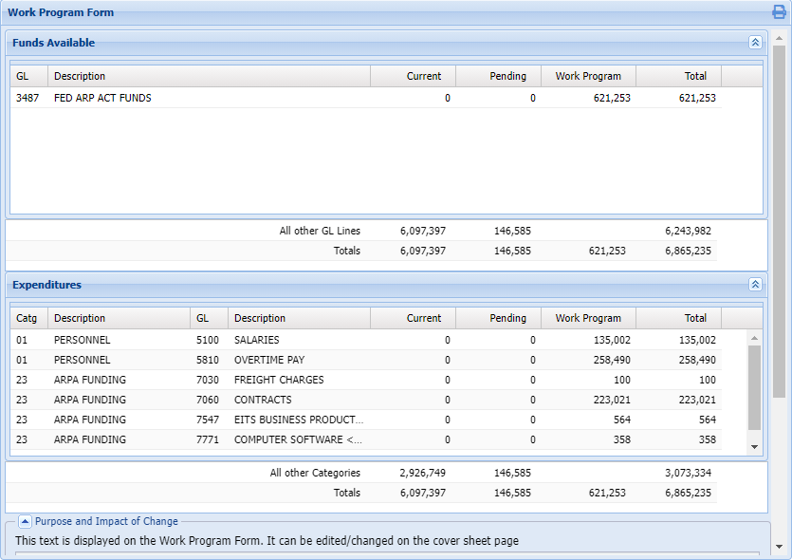
Purpose and Impact of Change
This field populates with the description entered on the Cover Sheet under the Purpose of Work Program section. Any revisions must be made within the Cover Sheet section and is completed by the requesting agency. It can be seen by anyone who views the work program when entering information into the Cover Sheet blocks. See additional information below.

Analyst’s Comments
This field is for Budget Division use and can only be seen by selected Budget Division staff.

Cover Sheet and Transmittal Memo
Additional details about a work program are entered or populated here (shown below). Some items can be inferred from existing NEBS data while others must be entered by the user requesting the work program.
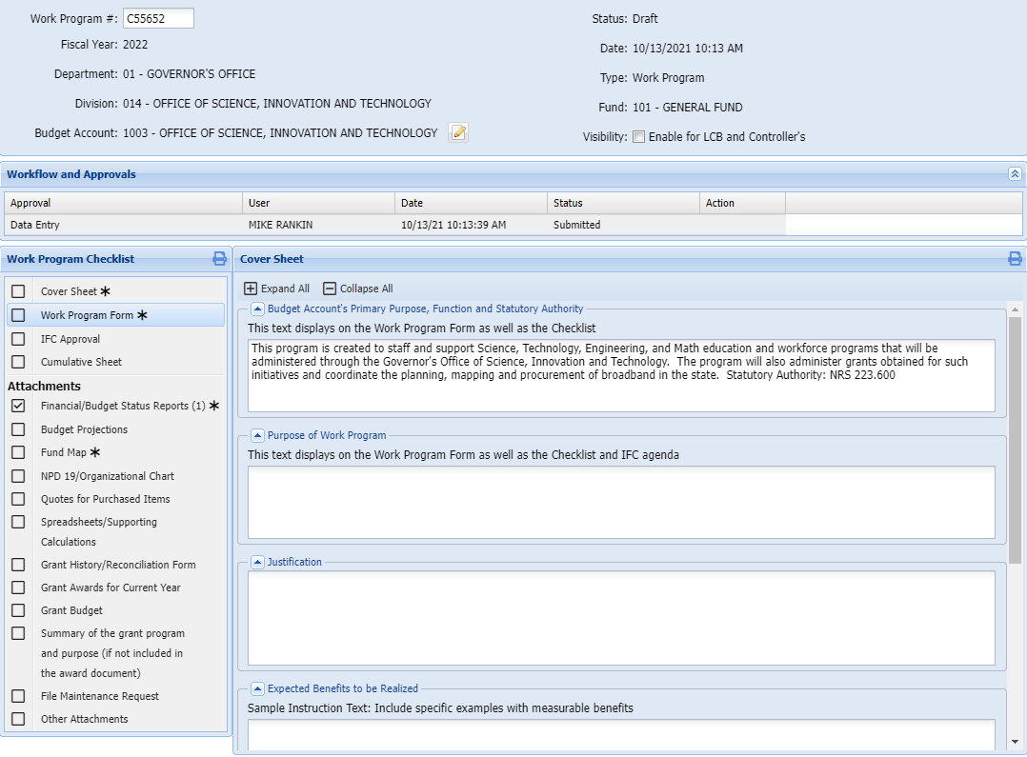
Header data - This is boilerplate text specific to the department, division, and budget account. The header includes the department name, fund, budget account name, work program number, and the fiscal year.

Date - The work program date will be the date of the final agency approval is given and will be populated by NEBS.

Budget Account’s Primary Purpose, Function, and Statutory Authority - This field will be automatically drawn from the program statement already stored in NEBS for each budget account and can be edited as necessary.

Purpose of Work Program - Accurately and concisely describe why the work program is being requested and what it will accomplish.

Justification - Use this field to describe why the work program should be approved. State the practical effects on agency budget, policy, and on the state as a whole. Be concise and support any claims made. Justify all affected categories.

Expected Benefits to be Realized - Provide a list of the benefits to the State expected as a result of approval of the work program. Also include a description of the potential impact of not approving the work program. Support your claims and provide copies of any references mentioned.
Explanation of Projections and Documentation - List the documents attached and their relevance. Complete once the work program is finished.
Explanation of Alternatives and Why Current Proposal is Preferred – Please do not put NA. There always is an alternative, even if it isn’t a good one. Explain the consequences of not approving the work program and why it is preferred to move the work program forward.
Edits and Validations for the Submittal of the Work Program Request
NEBS will attempt to validate the information the user enters into the work program module. When NEBS detects the following problems, the user will be unable to submit the work program:
- Negative dollar amounts - individual GL and category amounts may not be adjusted below zero.
- Revenue and expenditure amounts are out of balance - total increases and decreases entered as part of the revenue and expenditure grids must balance.
- Missing required components - A work program may not be submitted without the following entries or attachments on the checklist page:
  - Checklist
  - Work program form and cumulative sheet
  - Transmittal memo
  - Financial and budget status reports
  - Fund map

Other issues NEBS detects will relate to total amounts of categories, sources of funding, and other characteristics of the work program.

These may not be actual errors and will not prevent you from submitting the work program, but will appear on a checklist page for your reference.

Workflow in the Work Program Module

Approval Process
The NEBS Work Program Module supports a multi-step approval workflow process, whereby, a work program can be ‘routed’ to the users who are required to review and approve or reject it. As a work program moves through the approval process, its status may change. A work program can be approved, modified, or rejected at each stage in the process. When the final approval for a work program is applied, it will be marked with ‘approved’ status. When a work program has been rejected, it will be marked as ‘rejected’ and the work program will no longer be shown in the pending amounts for the budget account. While a work program is still awaiting final approval, it will be marked as ‘pending’ and will be included in pending amounts for the budget account. Any approved or pending work program automatically populates on the cumulative sheet.

Security Roles
The security function for the Work Program Module is similar to the security function roles for individual NEBS users. These roles have been expanded to accommodate the particular security needs for each agency’s organizational structure for administering the work program process.

Individual User and Approval Roles
There are four approval roles for the Work Program Module. Only the work program department approver role is required for every agency. The other roles are optional and may be added to accommodate the approval process for your agency if needed. Depending on the agency internal approval process, the work program may require two, three, or all four approval levels. Typically, smaller agencies will require fewer levels than larger agencies. Each user must complete the individual confidentiality agreement security form for the NEBS work program module and it must be signed by the appointing authority. This form can be found on the Budget Division website. Users only have access to the specific budget accounts identified in their Work Program Module security profile.

Work Program Data Entry Users
This is an optional role. Users at this level can enter and modify draft work programs. Once the work program has been submitted to a higher-level approver, data entry users may not make any additional changes to the work program unless it is rejected back to this level or the user either removes or adds the work program.

Work Program Agency Budget Account Approver Users
This is an optional role. These users can perform data entry functions, apply agency budget account level approval, and submit the work program to the next level. Once the work program has been submitted to a higher level, budget account level users may not make changes unless the work program is rejected back to this level or the user either removes or adds the work program.

Work Program Division Approver User
This is an optional role. These users can perform data entry functions and can apply the division level approval to the work program. Once a work program has been submitted to the department level, a division level reviewer may not make additional changes unless the work program is rejected to this level or the user either removes or adds the work program.

Work Program Department Approver User
This role is required at each agency. Once the work program has been submitted to the Budget Division, the department level user may not make further changes unless the work program is rejected back to this level or the user either removes or adds the work program.

Budget Division Approvals
Once a work program has passed through the agency approvals, it will enter the Budget Division workflow. Budget Division roles are restricted and only applicable to Budget Division staff.

Approvals and Rejections
At each stage in the approval process, a work program is either approved or rejected through the use of the approval grid. When a reviewer views a work program that is pending approval, the grid appears at the top of the screen. The action column of the grid (shown below) indicates what actions can be performed. Simply click on the links in the action column to perform that action. If a user has already approved a work program and doesn’t have the authority to approve to the next level, then no link is available in the action column.

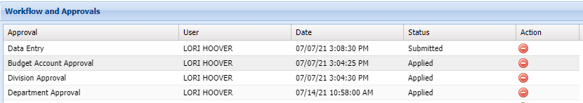

Approvals
At any stage in the process, when a reviewer approves a work program the following will occur:
- The reviewer’s name and a time stamp are added to the approval log.
- The reviewer will no longer be able to edit the work program.
- The work program moves on to the next reviewer.
- Work programs that now require user review will appear in the user ‘to do’ list.

If this is a work program that requires correction to one or more items, you may either reject the entire work program or you may edit it.

Rejections
If you want one of the prior reviewers or the user who entered the work program to make a change, reject the work program. Selecting one of the minus button levels in the approval grid removes all approvals down to and including the selected level. The work program will again appear on the users ‘to do’ list. The users at this level may make the change or reject the work program to a lower level if appropriate. If the user chooses to reject the work program to a lower level, the original rejection note will disappear. In this case, the user may want to copy the original rejection note and reattach it or email it to the lower level.

Editing
Instead of rejecting a work program that requires corrections, a reviewer may elect to edit it by clicking the modify button. As long as a reviewer’s status still shows as ‘pending’ they may edit and make changes to a work program that is in the process of being approved.

Submit Work Program Request to Next Approval Level
Once the work program request is completed and ready to submit to the next approval level, navigate to the bottom of the screen and click the Submit button. If NEBS finds an error when it validates the work program, the submission will fail and an error message will appear.

When a work program is successfully submitted to the next approval level, it will be removed as a draft from the personal ‘to do’ list and appear on the next approval level’s ‘to do’ list as pending approval. Once the work program moves to the next approval level, the user will have read-only access to it unless it is rejected back or is retrieved prior to the next level’s approval.

Permanent Deletion from the System
To permanently delete a work program from the system, the work program must be in “Draft” status and at the data entry level. If these two conditions are met, an active “delete” button will appear at the bottom of the screen for use. If the person who drafted the work program (data entry user) is no longer at the agency, you must re-assign the work program to another current user in order to delete it. To request re-assignment you must email your assigned Budget Officer (include the work program number and the new user name).

The delete button is now provided (shown below) for the data entry user anytime the work program is pending at the data entry level. The user should be careful to not delete when the actual intent is to print. A pop-up window appears when deleting. It is important to read the window to avoid an error. Work Programs deleted in error are not recoverable.

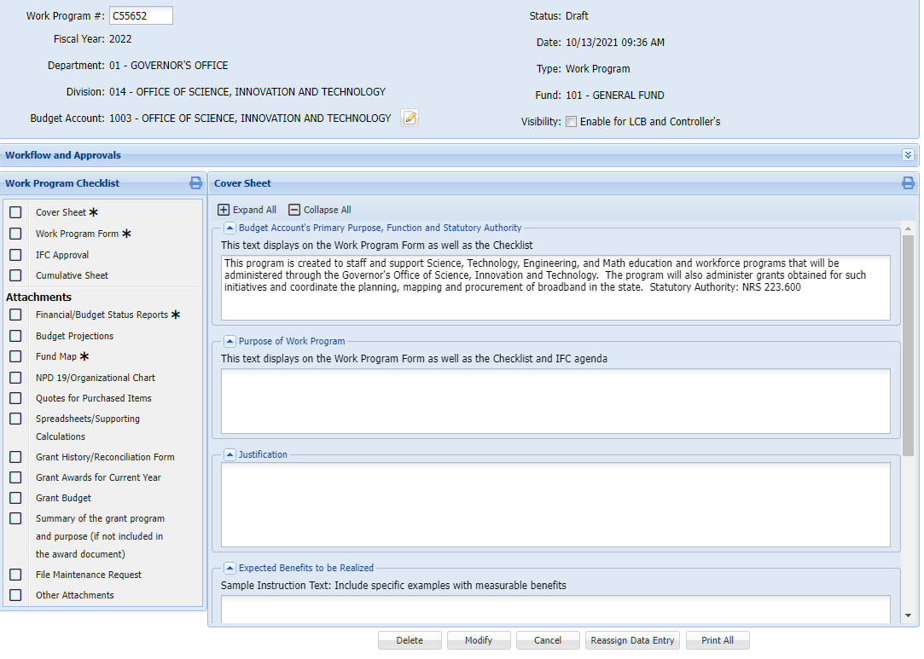

Reporting in the Work Program Module

Printing and Viewing Reports
Individual reports can be printed by clicking on the desired report and then clicking the print icon (shown below).

To print the entire work program request to a PDF, click the Print All button at the bottom of the View
Work Program screen. A file download window will appear. Click the open button to view the various components of the work program request.

The work program forms will appear and print in the following order:
- Work Program Form
- Work Program Checklist
- Cover Sheet
- Cumulative Sheet(s)
- Attachments

Cumulative Modification Worksheet
This report lists a single percent change column for the total of all work program changes. It draws from the legislatively approved budget as well as any previous work programs that affect the current budget. Current, prior approved and pending work programs will be shown on the cumulative sheet. The order of the work programs printed in the columns labeled ‘First,’ ‘Second,’ ‘Third,’ etc., will be based upon the following rules:
- Approved work programs will be listed first in the order of approval.
- Next will be work programs transmitted to IFC based on the order of transmittal (sequence number assigned).
- Following these will be work programs submitted to the Budget Division in the order that they were approved at the agency level (approval date and time).
- Work programs that have not reached the step in the workflow process that defines a date will not be shown.

Watch for any instances of “TITLE NEEDED” on this form (shown below). This will appear when adding a new category or revenue GL.
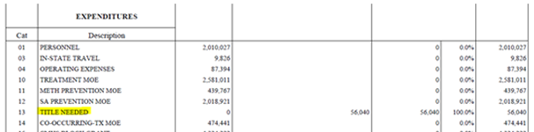

If this occurs, add a title for the category or revenue GL by clicking the pencil and paper icon in the heading area (shown below).

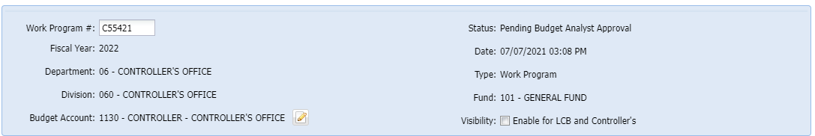

Continue to communicate with the assigned Budget Officer regarding agency work programs. Providing details of the event and supporting documentation will help the assigned Budget Officer relay accurate information to appropriate inquiring entities. Submitting a professional work program package and working together will ensure the success of state agencies and build a positive working environment.

